Understanding Gradient Descent

To explain Gradient Descent we will use the classic mountaineering example.
Suppose you are at the top of a mountain, and you have to reach a lake which is at the lowest point of the mountain (a.k.a valley). A twist is that you are blindfolded and you have zero visibility to see where you are headed. So, what approach will you take to reach the lake?
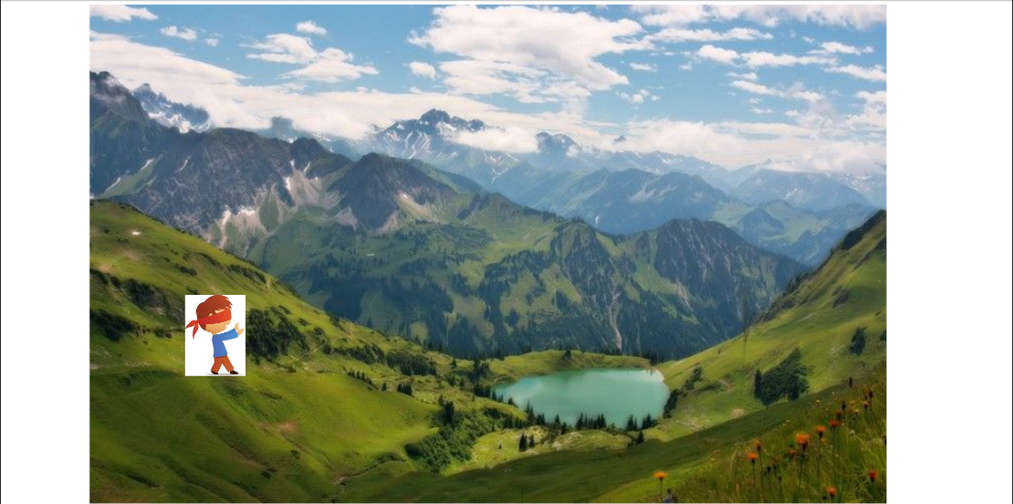
Source
The best way is to check the ground near you and observe where the land tends to descend. This will give an idea in what direction you should take your first step. If you follow the descending path, it is very likely you would reach the lake.
To represent this graphically, notice the below graph.
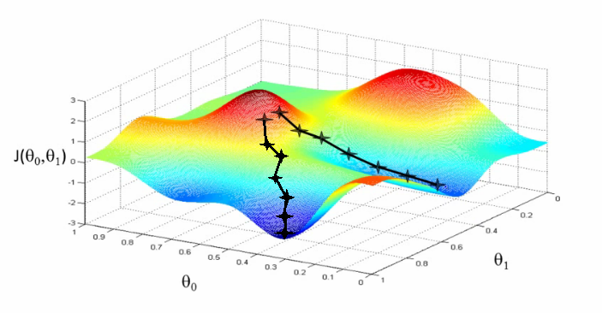
Source
Let us now map this scenario in mathematical terms.
Suppose we want to find out the best parameters (θ1) and (θ2) for our learning algorithm. Looked at the above image, you can see that on the x-axis, we have one parameter (θ1), on y-axis, we have parameter (θ2) and z-axis has cost function J(θ). Cost space is nothing but how our algorithm would perform when we choose a particular value for given parameter(s).
Here, hills are represented by red region, which have high cost, and valleys are represented by blue region, which have low cost.

To learn more about gradient descent, you can refer to this article.

